

**VOLUNTARIA**

**An Online Volunteer Management System**

By

Ashutosh Roy (1841107)

Debmalya Das (1841111)

K Prerana Udupa (1841136)

Vatsla Khurana (1841160)

Under the Guidance of

Dr. Prabu M

A Project report submitted in partial fulfillment of the requirements of IV **Semester of Bachelor of Computer Applications,**

CHRIST (Deemed to be University)

March-2020



CERTIFICATE

*This is to certify that the report titled Volunatria is a bona fide record of the work done by* ***Ashutosh Roy (1841111)****,* ***Debmalya Das (1841111)****,* ***K Prerana Ududpa (1841136)****,* ***Vatsla Khurana (1841160)*** *of CHRIST (Deemed to be University), Bangalore, in partial fulfilment of the requirements of VI Semester BCA during the year 2019.*

**Head of the Department Project Guide**

**Valued-by:**

|  |  |  |
| --- | --- | --- |
| 1 | Name | Ashutosh Roy 1841107  Debmalya Das 1841111  K Prerana Udupa 1841136  Vatsla Khurana 1841160 |
| 2 | Centre of  Examination | CHRIST (Deemed to be University) |
| 3 | Date of  Examination |  |

**ACKNOWLEDGEMENTS**

The project, Voluntaria, was successfully completed with the help of a lot of people. Firstly, We express our sincere gratitude to our Vice-Chancellor Dr. Fr. Abraham V M, Pro-Vice Chancellor Dr. Fr. Joseph CC, Head of the Department Prof. Joy Paulose, Coordinator Prof. Deepthi Das and the faculty for providing us with this priceless opportunity to put in and improve our technical skills and knowledge through this project.

We express our gratitude to our project guide Dr. Prabu M who took keen interest in helping and guiding us throughout our project work by providing all the necessary information for coming up with such a good result. We would also like to thank Dr. Arokia Paul Rajan for the ideas, continuous feedback and supervision on our project work.

We are thankful and fortunate enough to get constant encouragement, support and guidance from the faculty of BCA who helped us in successfully completing our project work. Also, we would like to extend our sincere esteems to all staff in the laboratory for their priceless support.

**ABSTRACT**

In a world where people are racing to reach their goals, it is not often that people stop and do something for others just for the sake of doing so and without any ulterior motives.  But there are organizations such as NGOs, colleges etc. where people come and volunteer in any event or program held by the organization without expecting payment. Volunteering is renowned for skill development and is often intended to promote kindness or improve human quality of life. Volunteering may have positive benefits for the volunteer as well as for the person or community served. It may also be helpful in making contacts for possible employment. Studies have also shown that volunteering can cause a decrease in loneliness for those volunteering as well as those for whom people volunteer. One of the more well-known benefits of volunteering is the impact on the community. Volunteering also allows you to connect to your community and make it a better place.

Giving to others can also help protect your mental and physical health. It can reduce stress, combat depression, keep you mentally stimulated, and provide a sense of purpose. While it’s true that the more you volunteer, the more benefits you’ll experience, volunteering doesn’t have to involve a long-term commitment or take a huge amount of time out of your busy day. Giving in even simple ways can help those in need and improve your health and happiness.

There is a need for more volunteers in our society and with that comes the necessity for a way to manage and organize these volunteers efficiently. Organizations might find it difficult to deal with volunteers based on certain events as some may be short term volunteers and some may be long term. And for a volunteer, he may be faced with an issue of not having any proof or commendation for the work he or she does. We have chosen this domain with the aim of helping such nonprofit organizations solve these problems by providing them with a way of accessing their user details easily and organize

without the hassle of having to send out multiple emails. The project also incorporates a way of providing the volunteer feedback and commendation certificates from the organization which may help them in the future.

There is no need to limit oneself to just one organization or one specific type of job. Sometimes an opportunity looks great on paper, but the reality is quite different. We also help the volunteer to pick the right role and organization for them as picking the right volunteer organization is like choosing a travel buddy for a life changing opportunity to touch others’ lives or do something for nature. The right match can help the volunteer to find friends, connect with the community, learn new skills, and even advance his/her career.

|  |  |  |
| --- | --- | --- |
| Serial No | Table Name | Page No. |
| Table 1.1 | Project plan | 12 |
| Table 4.1 | admin | 25 |
| Table 4.2 | event_info | 26 |
| Table 4.3 | gallery | 26 |
| Table 4.4 | volunteers | 27 |
| Table 4.5 | volunteer_info | 28 |

**List of Tables**

|  |  |  |
| --- | --- | --- |
| Serial No | Figure Name | Page No. |
| Fig 4.1 | Architectural Design | 23 |
| Fig 4.2 | volunteer_info | 30 |
| Fig 4.3 | event_info | 30 |
| Fig 4.4 | committee | 31 |
| Fig 4.5 | admin | 31 |
| Fig 4.6 | gallery | 31 |
| Fig 4.7 | DFD Level 1 | 32 |
| Fig 4.8 | DFD Level 2 | 32 |
| Fig 4.9 | DFD Level 3 | 33 |
| Fig 4.10 | DFD Level 4 | 33 |
| Fig 4.11 | DFD Level 5 | 33 |
| Fig 4.12 | DFD Level 6 | 34 |
| Fig 4.13 | Entity Relationship Diagram | 35 |
| Fig 4.14 | Sequence Diagram | 36 |
| Fig 4.15 | User Interface Diagram | 37 |
| Fig 6.1 | Admin Registration | 70 |
| Fig 6.2 | Volunteer Registration part A | 71 |
| Fig 6.3 | Volunteer Registration part B | 72 |
| Fig 6.4 | Event Details (Committee Creation) | 73 |
| Fig 6.5 | Volunteer Details (Committee Creation) | 74 |
| Fig 6.6 | Event Head Details (Committee Creation) | 75 |

**List of Figures**

**TABLE OF CONTENTS**

|  |  |
| --- | --- |
| Acknowledgements | III |
| Abstract | IV |
| List of Tables | VI |
| List of Figures | VII |
| 1. Introduction    1. Overview of the System    2. Project Description    3. Project Objective    4. Project Plan | 10  11  12  12 |
| 1. System Analysis    1. Existing Systems    2. Limitations of Existing Systems    3. Project Purpose    4. Project Scope    5. Project Applicability | 13  13  14  14  15 |
| 1. System Requirement    1. Problem Definition    2. Functional Requirements    3. User Stories    4. User Characters    5. Software Requirements   3.6 Hardware Requirements | 16  16  19  19  20  22 |
| 1. Design Specification   4.1 Architectural Design   * 1. Database Dictionary   2. Table Design   3. Data-Flow Diagrams   4. Entity relationship Diagram   5. Sequence Diagram   6. User Interface Design | 24  26  30  32  35  36  37 |
| 1. Implementation    1. Source Code | 38 |
| 1. Testing   6.1 Test Strategies  6.2 Test Cases  6.3 Test Reports | 67  68  70 |
| 1. Conclusion   7.1 Limitations  7.2 Future Enhancement | 76  76 |
| **Reference** |  |

**TABLE OF CONTENTS**

1. **INTRODUCTION**
   1. **OVERVIEW OF THE SYSTEM:**

In a world where people are racing to reach their goals, it is not often that people stop and do something for others just for the sake of doing so and without any ulterior motives.  But there are organizations such as NGOs, colleges etc. where people come and volunteer in any event or program held by the organization without expecting payment. Volunteering is renowned for skill development and is often intended to promote kindness or improve human quality of life. Volunteering may have positive benefits for the volunteer as well as for the person or community served. It may also be helpful in making contacts for possible employment. Studies have also shown that volunteering can cause a decrease in loneliness for those volunteering as well as those for whom people volunteer. One of the more well-known benefits of volunteering is the impact on the community. Volunteering also allows you to connect to your community and make it a better place.

Giving to others can also help protect your mental and physical health. It can reduce stress, combat depression, keep you mentally stimulated, and provide a sense of purpose. While it’s true that the more you volunteer, the more benefits you’ll experience, volunteering doesn’t have to involve a long-term commitment or take a huge amount of time out of your busy day. Giving in even simple ways can help those in need and improve your health and happiness.

There is a need for more volunteers in our society and with that comes the necessity for a way to manage and organize these volunteers efficiently. Organizations might find it difficult to deal with volunteers based on certain events as some may be short term volunteers and some may be long term. And for a volunteer, he may be faced with an issue of not having any proof or commendation for the work he or she does. We have chosen this domain with the aim of helping such nonprofit organizations solve these problems by providing them with a way of accessing their user details easily and organize events without the hassle of having to send out multiple emails. The project also incorporates a way of providing the volunteer feedback and commendation certificates from the organization which may help them in the future.

There is no need to limit oneself to just one organization or one specific type of job. Sometimes an opportunity looks great on paper, but the reality is quite different. We also help the volunteer to pick the right role and organization for them as picking the right volunteer organization is like choosing a travel buddy for a life changing opportunity to touch others’ lives or do something for nature. The right match can help the volunteer to find friends, connect with the community, learn new skills, and even advance his/her career.

**1.2 PROJECT DESCRIPTION:**

Voluntaria, our volunteer management system is a project that aims to make the work of organizations that allow people who are not employed by that organization to volunteer for events, easier. Managing a large number of people, this usually leads to mistakes as the workload of the event organizers increases. Today management is one of the most essential features of all systems. Our project makes organizing an event easier as it takes a load off their shoulders with having to do any attendance checks or background verifications manually and also helps to provide the volunteers with reference letters or commendation certificates once the event is done. Basically, our project deals with the management of the volunteers for a certain event from start to finish

**1.3 PROJECT OBJECTIVE:**

The sole objective of this project is to provide an intelligent application to the non-profit organizations that can assist them in managing the volunteers for the event and make the event execute smoothly.

**1.4 PROJECT PLAN**

Table 1.1 Project Plan

|  |  |
| --- | --- |
| DATE | PHASE |
| 5th November - 18th November | Finalized the concepts of project |
| 19th November - 25th November | Analysis Phase |
| 26th December - 19th December | User Interface Designing |
| 20th December - 20th February | Designing of the Database & Connecting to the Database |
| 21st February – 29th February | Testing |
| 1st March – 11th March | Final report submission |

1. **SYSTEM ANALYSIS**

**2.1 EXISTING SYSTEMS:**

The growth of Science and Technology has led to the development of similar systems that can help an organization manage their volunteers for their events, such as,

**2.1.1 Volunteer Impact:**

Volunteer Impact is a volunteer management software that helps both large national and regional organizations to recruit, track, and schedule volunteers across a variety of sectors within five countries. Industries include social service, health, environmental, animal welfare, sporting events, and festivals.

**2.1.2 Volgistics:**

Volgistics is a web-based software with a user-friendly interface that manages past, current and future volunteers and coordinators. Users can assign and track roles within many types of organizations from small local animal shelters to large international services.

**2.2 LIMITATIONS OF EXISTING SYSTEMS:**

1. Despite the recruiting feature in the existing systems, they fail to come up with a certification/recognition system which will add to the work done by volunteers.
2. The existing system also fails at time to be user friendly for the organization using it because there are numerous processes for properly implementing the system.

**2.3 PROJECT PURPOSE:**

Voluntaria is the one stop solution for managing the volunteers for any events irrespective of its scale. We facilitate organizations be it NGO, colleges, schools etc. to aid them in organizing their events in hassle-free and convenient manner. We aim to be one step ahead of an existing system and also provide the volunteers feedback and commendation certificates or reference letters after the event is done based on their performance and the number of hours put in. We will also introduce ways in which to check if the organization that registers with us is legal and also help the organization perform a background check or identity verification for the volunteers who sign up in their event.

The **main outcomes** of this project are to maintain and manage volunteer and event information. Some of the other benefits are listed below.

• Easy and efficient volunteer management.

• Backup volunteer option.

**2.4 PROJECT SCOPE:**

Organizations like NGOs are an important part of our country’s development. There are many areas in our country that need help. Involvement of people and their contribution towards these areas can benefit our country in more ways than one and this should be encouraged as much as possible. Sometimes these organizations might not be able to accumulate a large number of volunteers due to management problems but our project allows them to look beyond this problem and provide a platform through which more people can be encouraged to volunteer for the good of our nation without any problems.

**2.5 PROJECT APPLICABILITY:**

The prime and direct area of application is for Non-Profit Organizations such as NGOs, universities and schools. We primarily focus on NGOs as they are an important part of our society’s welfare. Help out injured wildlife, change the way math is taught, or commit to cleaning up the city with a list of volunteer-friendly NGOs in your city. Doing what you love might help make someone’s life better. This application will be very useful and can be easily adopted in these non-profit organizations.

1. **SYSTEM REQUIREMENT**

This phase is a crucial part of our project and forms the base for all our future processes of development. We focused on analyzing the proposed and existing system and gathering the accurate requirements from our clients. The analysis being done in various parts of this phase helps us understand the actual user requirements and will help us form a good input for our system design and provide us with a way to make our system easily understandable and user-friendly.

**3.1 PROBLEM DEFINITION:**

A voluntary organization’s workload is every time distributed among a set of voluntary people who offers to help the organization in conducting their events. Since the entire work duty being voluntary, it becomes difficult to manage the volunteer’s work details in paper due to which it becomes difficult to track and acknowledge the work that they are doing.

A voluntary would also need diverse set of volunteers every single time they conduct an event, which is why getting people to volunteer on their free will becomes a problem. A volunteer management system comes with the solution of these two major problems and eventually pull in all loose strings which are related to them.

* 1. **FUNCTIONAL REQUIREMENTS:**
     1. **Access mode:** The admin of the organization who is in charge of the organization will be in charge of both the management side and volunteer side. The event head will be given access to the database and control settings of that particular event, similarly having access to both sides, but specifically for the event that he is heading. Registered volunteers will be able to access their profile details and work desk only.

**Dashboard Displays in Web pages:** There will be 3 main web-pages, with displayed details, which is as follows:

* + 1. Web page 1: This webpage will contain all the details of current events of all the companies who have hired the volunteer management system
    2. Web page 2: This webpage will contain the details and updates of an event of a particular organization. This webpage will be accessible only to any previously verified volunteer and to new volunteers and the respective event heads.
    3. Web page 3: This is the webpage that will contain a detailed explanation of a particular event. It will also contain the volunteer details and the event organizer details and further detailed updates regarding specific tasks for the particular event will be updated in this web page. This web page will only be accessible to the elected vent head and the registered volunteer.
    4. **Volunteer and Event record portability:**  Volunteer details should be transferrable throughout the volunteer management system for all the admins and the event heads.
    5. **Registration of event, volunteers and event tasks:** Admins should able to register or create an event and get volunteers registered for the same and check and verify their details. Event heads will be able to create Volunteer specifications according to the task specification of the particular event. Event head will be able to update tasks for the event.
    6. **Event Management:** Event heads will be able to handle the event details and the details of the volunteers who have registered for the particular event. The event head will be able to check the work desk of the volunteers and update their tasks accordingly. The event head will be at the liberty to register volunteers according to the specific task of the particular event.
    7. **Volunteer Tracking:** The event head and the admin will be able to access the work details of the volunteers and track them accordingly.
    8. **Search:** There should be search option for admin and event head to search details for other events and the overall volunteers who have registered for the organization. The volunteers on the other hand will be able to search for the registered companies and events of the respective companies who have hire the volunteer management system.
    9. **Lists:** The list of voluntary organization will have public accessibility. The voluntary organization will contain an event list for volunteers to register for an event. The specific event will have a list of tasks for which the volunteer will be able to sign up.
  1. **USER STORIES**

The high-level client requirements in terms of user stories are given as below:

* The system should provide access to Volunteers, Managers and Organizers with defined privilege set for each.
* The system should provide the background check for the volunteers registering by verifying their Government ID.
* Volunteers should be able to register in any event, choose their roles, view their performance.
* Volunteers can get rewards and referrals attested by the event organizers.
* Event managers should be able to assign tasks, track work performance & provide updates to the organizers about the progress.
* Event organizers should be able manage the access definitions and functionality privileges of the application.

**3.4 USER CHARACTERS:**

**Users**

1) Volunteers:

* Volunteers should be able to register in any event, choose their roles, view their performance.

2) Event Managers:

* They should be able to select the volunteers based on their rating and can also access their past performance from the database.
* They monitor the activities of the volunteers in the event i.e., take their attendance, track their work progress.
* They can add work updates for the volunteers.
* They are responsible for deciding the rewards for volunteers which later can be approved by the event organizers.

3) Admins of the Organization:

* They should be to should be able to Add / Remove / Modify the events specifying the no. of volunteers / type of event.
* They can specify the roles for the other users i.e., Managers, Volunteers by adding/ removing them based on the needs of the event.
* They can specify the roles & the level of access for the volunteers as well as the event managers.

They attest the work performance reports of the volunteers & are at the liberty to decide the rewards based on their performance.

* 1. **SOFTWARE REQUIRMENTS / TOOLS**

**XAMPP**

XAMPP software package contains Apache distributions for Apache server, MariaDB, PHP, and Perl. And it is basically a local host or a local server. This software is installed on the laptop or desktop and is used to test the clients or your website before uploading it to the remote web server or computer.

**Apache**

Apache server is an open source free software which is initially developed by a group of software developers and now it is maintained by Apache software foundation. Apache HTTP is a remote server. If someone request files, images or documents using their browser they will serve those files to clients using HTTP servers. Mainly hosting companies use this application to create a VPS server and shared hosting for their clients.

**MYSQL**

MYSQL is an open source software. It is actually a relational database management system (RDBMS). This SQL stands for Structured Query Language. It is the most popular and best RDBMS used for developing a variety of web-based software applications. With the help of MYSQL, it is possible to organize the information, manage, retrieve and update the data whenever you wish to do.

**PHP**

It is a server-side scripting language that helps you to create dynamic websites. This language is mainly used to build web-based software applications. It is an open source software and works fine with MYSQL. What actually happens is, the PHP code will be executed on the server and at the browser side its HTML code will be displayed.

**HTML 5**

HTML5 is a software solution stack that defines the properties and behaviors of web page content by implementing a markup-based pattern to it. HTML5 was the fifth and current major version of HTML that is a World Wide Web Consortium recommendation.

**JavaScript**

JavaScript, often abbreviated as JS, is a programming language that conforms to the ECMAScript specification. JavaScript is high-level, often just-in-time compiled, and multi-paradigm. It has curly-bracket syntax, dynamic typing, prototype-based object-orientation, and first-class functions.

**Visual Studio Code**

Visual Studio Code is a source-code editor developed by Microsoft for Windows, Linux and macOS. It includes support for debugging, embedded Git control and GitHub, syntax highlighting, intelligent code completion, snippets, and code refactoring.

**Bootstrap 4**

Bootstrap 4 is the newest version of Bootstrap, which is the most popular HTML, CSS, and JavaScript framework for developing responsive, mobile-first websites. Bootstrap 4 is completely free to download and use.

**3.5 HARDWARE REQUIREMENTS:**

Since our working model will be website. The only requirements are PC or phone with an internet access. But the minimum requirements are as follows:

**Processer:**

* Minimal: 1.6 GHz CPU
* Recommended: 2.0 GHz CPU

**RAM:**

* Minimal: 1.75 GB RAM
* Recommended: 2 GB RAM

**HDD:** 20 GB and more is recommended (Non-system drive is preferred).

**Display Unit:** EGA/VGA Color Monitor with a resolution of minimum 1024 X 768 and higher.

**Network:** Internet Connection Broadband (high-speed) Internet connection with a speed of 4 Mbps or higher.

**4. DESIGN SPECIFICATION**

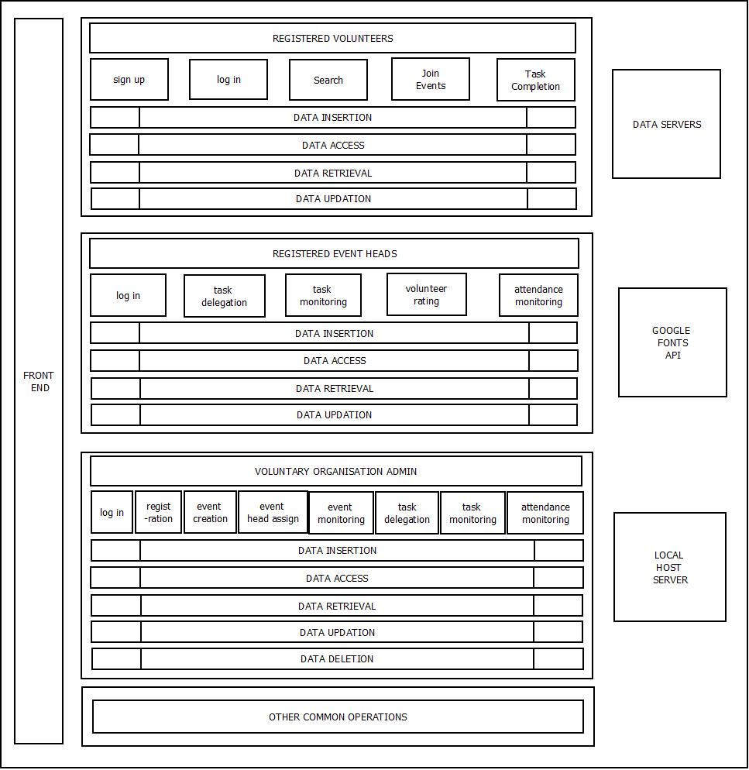**4.1 ARCHITECTURAL DESIGN**

Fig 4.1 Architectural Design

**4.1.1 Registration:**

The Volunteers can register to Voluntaria with their own set of preferences along with their required official details. The Voluntary Organization can register initially with one Admin and its Official details

**4.1.2 Event Creation:**

The admin of the Voluntary Organization can create events with necessary volunteer specifications along with all the official details required for information on conducting the event.

**4.1.3 Committee Creation:**

The creation of all necessary committees is done during the creation of event. The Admin needs to specify the required no of Volunteers of each committee.

**4.1.4 Assigning an Event Head:**

The Admin assigns an event head for each of the event using a back end of operation (creation of Event Head ID and Password), to ensure proper functioning of all the committees.

**4.1.5 Searching and joining an event:**

The Volunteers in Voluntaria are allowed to search for the events which matches to their preference and join that event in a specific committee. The event gets added up to their profile.

**4.1.5 Task Scheduling and tracking:**

The event head delegates work to each committee either specific to Volunteer or common to all the volunteers present in the committee. The Event Head can track and monitor the work being done. Similarly, the volunteer can update and keep a track of the work being done. The Admin is allowed access to this operation.

**4.1.6 Performance Evaluation:**

On completion of the work of a committee, the event head can rate a volunteer on the basis of the work that they have done on or off the field or the work submitted. The rating builds the profile of the Volunteer. The Admin is allowed access to this operation.

**4.2 DATABASE DICTIONARY**

**4.2.1 Data Dictionary:**

Table4.1 admin

|  |  |  |  |
| --- | --- | --- | --- |
| **Column** | **Type** | **Null** | **Default** |
| organization_name | varchar(50) | No |  |
| organization_type | varchar(30) | No |  |
| admin_name | varchar(50) | No |  |
| gender | varchar(30) | No |  |
| username | varchar(30) | No |  |
| pass | varchar(20) | Yes | *NULL* |
| organization_id *(Primary)* | int(10) | No |  |
| phone | bigint(10) | No |  |
| email | varchar(30) | No |  |

Indexes

|  |  |  |  |  |  |  |  |
| --- | --- | --- | --- | --- | --- | --- | --- |
| **Keyname** | **Type** | **Unique** | **Packed** | **Column** | **Cardinality** | **Collation** | **Null** |
| PRIMARY | BTREE | Yes | No | organization_id | 4 | A | No |
| organization_name | BTREE | Yes | No | organization_name | 4 | A | No |
| phone | BTREE | Yes | No | phone | 4 | A | No |
| email | BTREE | Yes | No | email | 4 | A | No |

Table 4.2 event_info

|  |  |  |  |
| --- | --- | --- | --- |
| **Column** | **Type** | **Null** | **Default** |
| event_name | varchar(50) | No |  |
| event_type | varchar(20) | No |  |
| event_time | time | No |  |
| event_date | date | No |  |
| location | varchar(30) | No |  |
| admin_name | varchar(30) | No |  |
| admin_email | varchar(30) | No |  |
| admin_phone | bigint(20) | No |  |
| address | varchar(50) | No |  |
| event_id (Primary) | int(10) | No |  |
| event_status | varchar(3) | Yes | on |
| organization_id | int(11) | No |  |

Indexes

|  |  |  |  |  |  |  |  |
| --- | --- | --- | --- | --- | --- | --- | --- |
| **Keyname** | **Type** | **Unique** | **Packed** | **Column** | **Cardinality** | **Collation** | **Null** |
| PRIMARY | BTREE | Yes | No | event_id | 8 | A | No |
| organization_id | BTREE | No | No | organization_id |  | A | No |

Table 4.3 gallery

|  |  |  |  |
| --- | --- | --- | --- |
| **Column** | **Type** | **Null** | **Default** |
| event_id *(Primary)* | int(11) | No |  |
| pic1 | blob | No |  |
| pic2 | blob | Yes | *NULL* |
| pic3 | blob | Yes | *NULL* |

Indexes

|  |  |  |  |  |  |  |  |
| --- | --- | --- | --- | --- | --- | --- | --- |
| **Keyname** | **Type** | **Unique** | **Packed** | **Column** | **Cardinality** | **Collation** | **Null** |
| PRIMARY | BTREE | Yes | No | event_id | 0 | A | No |

Table 4.4 volunteers

|  |  |  |  |
| --- | --- | --- | --- |
| **Column** | **Type** | **Null** | **Default** |
| email_ID *(Primary)* | varchar(100) | No |  |
| vname | varchar(50) | No |  |
| event_id *(Primary)* | int(11) | No |  |

Indexes

|  |  |  |  |  |  |  |  |
| --- | --- | --- | --- | --- | --- | --- | --- |
| **Keyname** | **Type** | **Unique** | **Packed** | **Column** | **Cardinality** | **Collation** | **Null** |
| PRIMARY | BTREE | Yes | No | email_ID |  | A | No |
| event_id | 0 | A | No |

Table 4.5 volunteer_info

|  |  |  |  |
| --- | --- | --- | --- |
| **Column** | **Type** | **Null** | **Default** |
| vname | varchar(50) | No |  |
| dob | date | No |  |
| gender | varchar(20) | No |  |
| email_ID | varchar(50) | No |  |
| phone | bigint(20) | No |  |
| state | varchar(20) | No |  |
| city | varchar(20) | No |  |
| profession | varchar(50) | No |  |
| bloodgrp | varchar(10) | No |  |
| pass | varchar(20) | No |  |

Indexes

|  |  |  |  |  |  |  |  |
| --- | --- | --- | --- | --- | --- | --- | --- |
| **Keyname** | **Type** | **Unique** | **Packed** | **Column** | **Cardinality** | **Collation** | **Null** |
| email_ID | BTREE | Yes | No | email_ID | 6 | A | No |

**4.3 TABLE DESIGN**

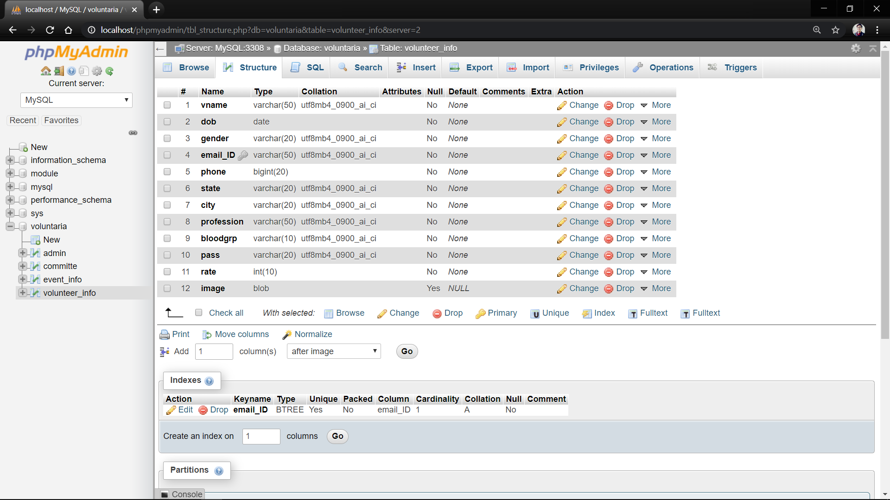

Fig 4.2 volunteer_info

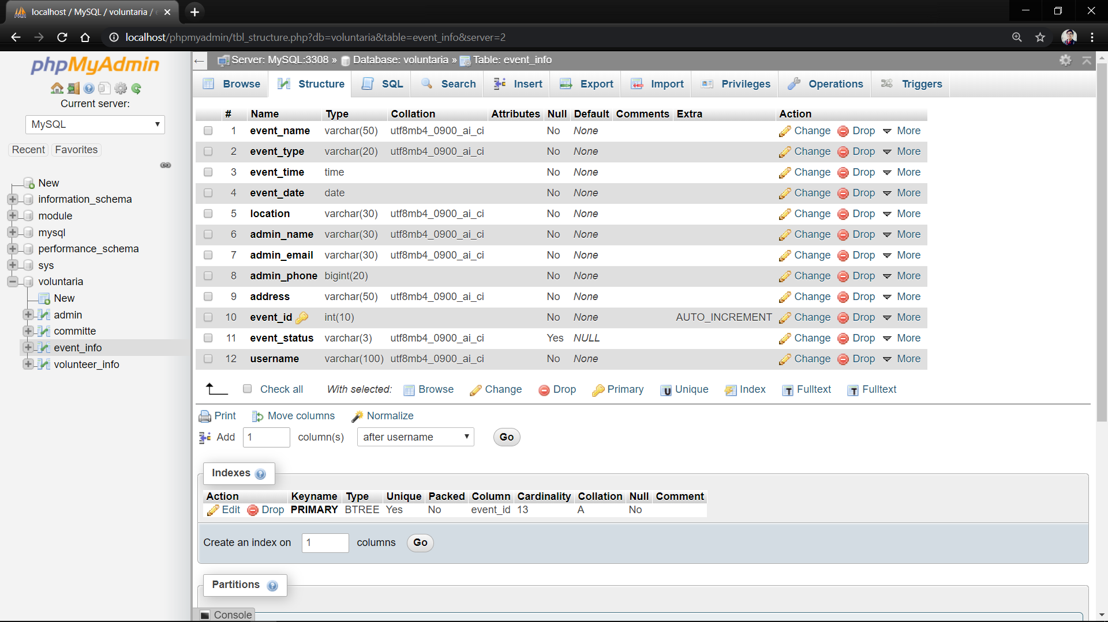

Fig 4.3 event_info

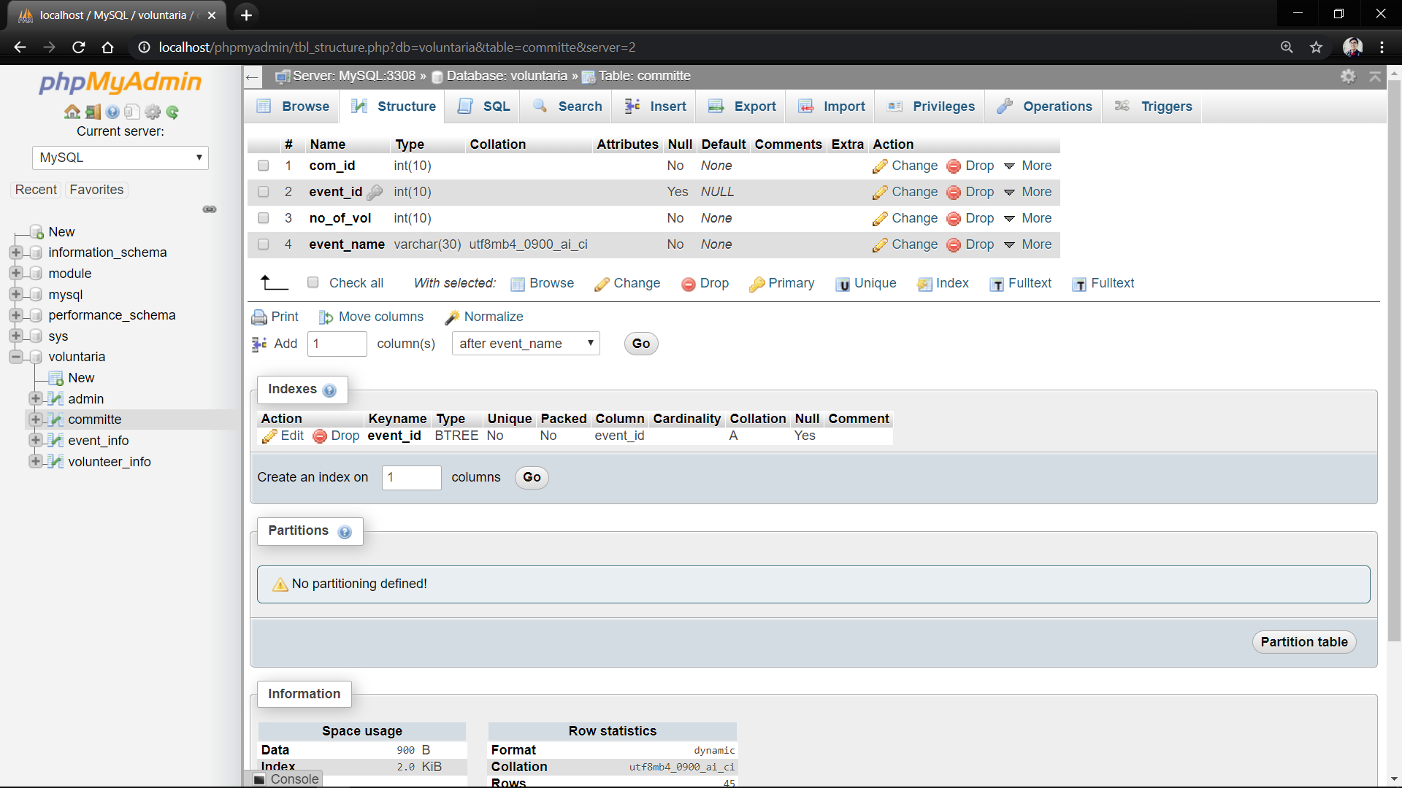

Fig.4.4 committee

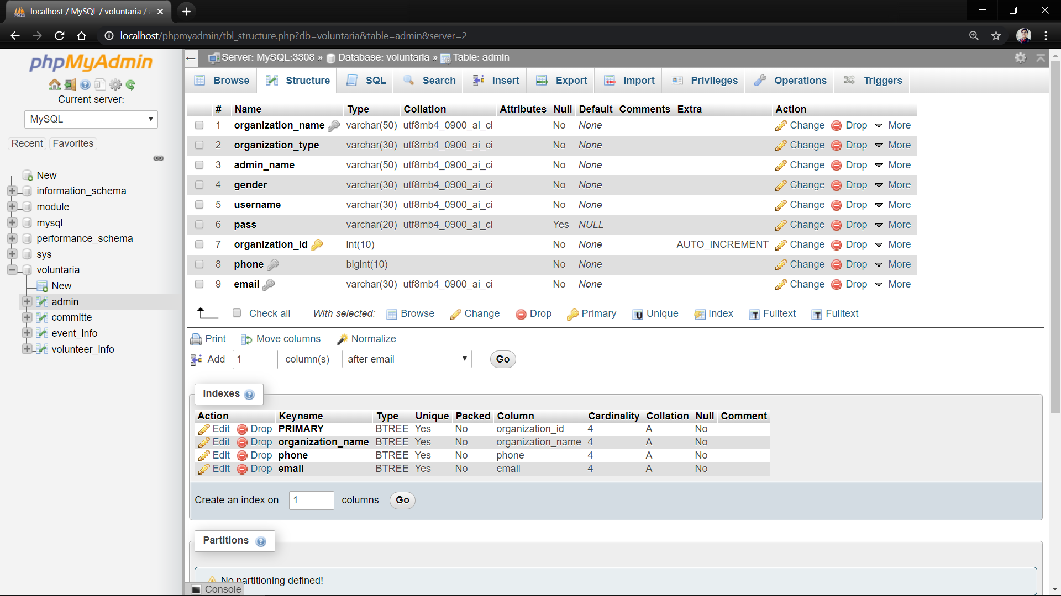

Fig 4.5 admin

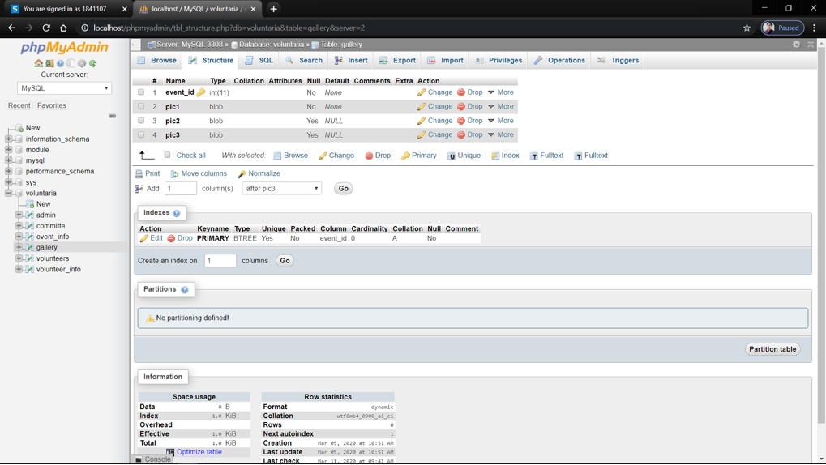

Fig 4.6 gallery

**4.4 DATA-FLOW DIAGRAMS**

**Level 1:**

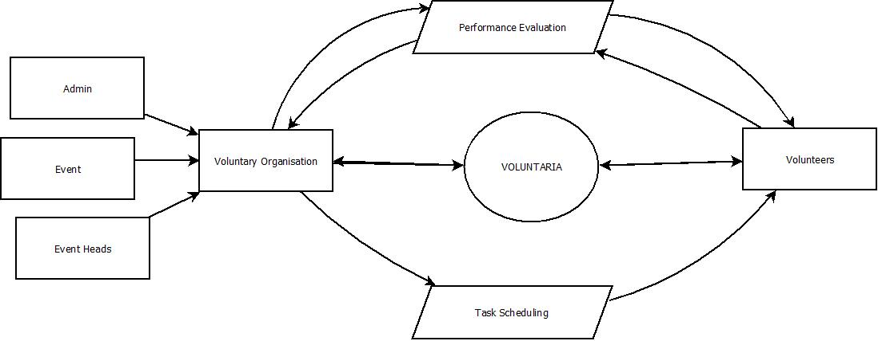

Fig 4.7 Data Flow Diagram, Level 1

**Level 2:**

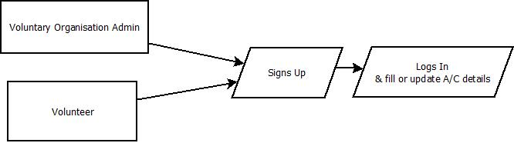

Fig 4.8 Data Flow Diagram, Level 2

**Level 3 :**

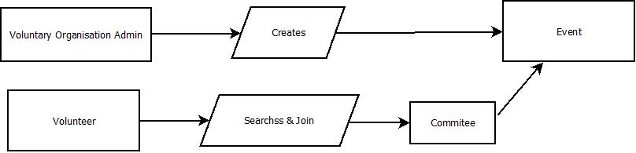

Fig 4.9 Data Flow Diagram, Level 3

**Level 4:**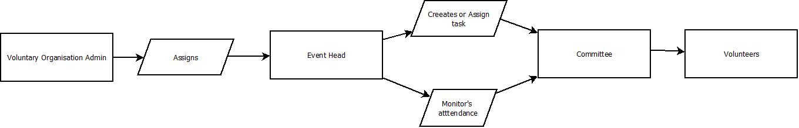

Fig 4.10 Data Flow Diagram, Level 4

**Level 5:**

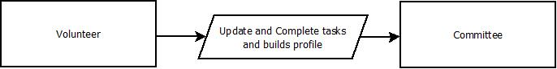

Fig 4.11 Data Flow Diagram, Level 5

**Level 6:**

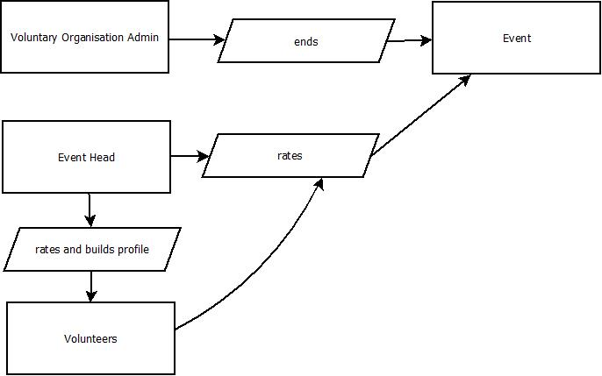

Fig 4.12 Data Flow Diagram, Level 6

**4.5 ENTITY RELATIONSHIP DIAGRAM :**

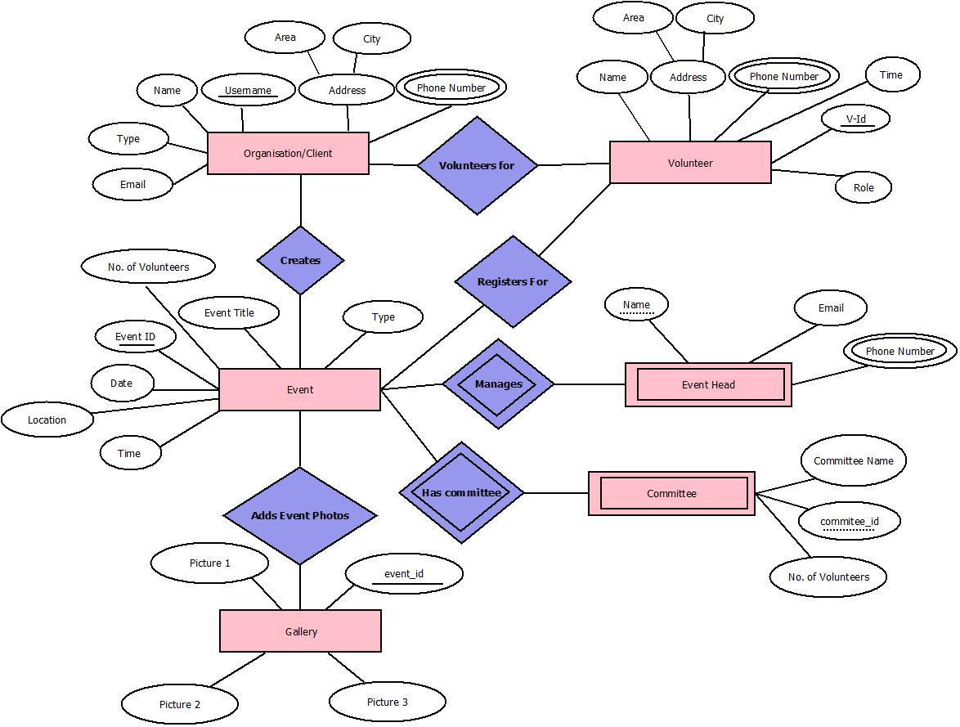

Fig 4.13 Entity Relationship Digram

**4.6 SEQUENCE DIAGRAM**

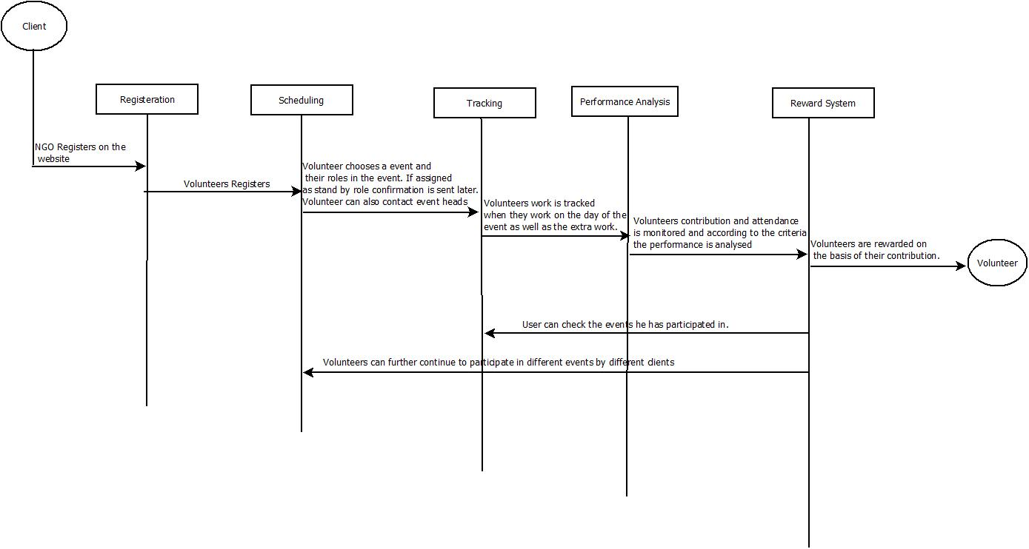

Fig 4.14 Entity Sequence Diagram

**4.7 USER INTERFACE DESIGN**

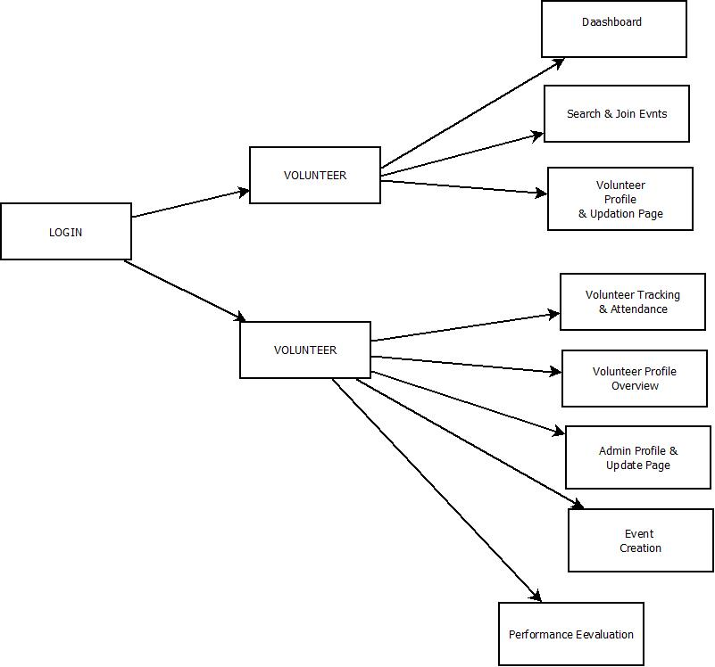

Fig 4.15 User Interface Design

**5. IMPLEMENTATION**

**5.1 SOURCE CODE**

**SIGN UP PAGE FOR ADMIN**

<?php

$organization = $_POST['organization'];

$type = $_POST['type'];

$first_name = $_POST['first_name'];

$username = $_POST['username'];

$password = $_POST['cpassword'];

$email = $_POST['email'];

$gender= $_POST['gender'];

$phone = $_POST['phone'];

if (!empty($company) ||!empty($type) || !empty($first_name) || !empty($username) || !empty($password) || !empty($gender) || !empty($email) || !empty($phone))

{

    $host = "localhost";

    $dbUsername = "root";

    $dbPassword = "";

    $dbname = "voluntaria";

    //create connection

    $conn = new mysqli($host, $dbUsername, $dbPassword, $dbname);

    if (mysqli_connect_error())

    {

        die('Connect Error('. mysqli_connect_errno().')'. mysqli_connect_error());

    }

    else

    {

        $echeck="select email from admin where email=".$_POST['email'];

        $echk=mysql_query($echeck);

        $ecount=mysql_num_rows($echk);

        $echeck1="select phone from admin where phone=".$_POST['phone'];

        $echk1=mysql_query($echeck1);

        $ecount1=mysql_num_rows($echk1);

        if($ecount!=0)

        {

            echo "Email already exists";

        }

        if($ecount1!=0)

        {

            echo "Phone Number already exists";

        }

        else

        {

            $sql="INSERT Into admin(organization_name,organization_type,admin_name, gender, username, password, organization_id,phone,email)

            values('$organization', '$type', '$first_name', '$gender', '$username', '$password','1871108', '$phone', '$email')";

            if ($conn->query($sql))

            {

                echo "New record inserted sucessfully";

            }

            else

            {

                echo "Error: ". $sql ." ". $conn->error;

            }

            $conn->close();

        }

    }

}

else

{

    echo "All field are required";

    die();

}

?>

**LOGIN PAGE FOR ADMIN**

<?php

    session_start();

    $message="";

        if(count($_POST)>0)

        {

            $con = mysqli_connect('localhost:3308','root','','voluntaria') or die('Unable To connect');

            $result = mysqli_query($con,"SELECT * FROM admin WHERE username='" . $_POST["username"] . "' and pass = '". $_POST["pass"]."'");

            $row  = mysqli_fetch_array($result);

            if(is_array($row)) {

            $_SESSION["organization_id"] = $row['organization_id'];

            $_SESSION["username"] = $row['username'];

            echo "correct";

            if(isset($_SESSION["organization_id"]))

            {

                header("Location:adminpro.php");

            }

            }

            else

           {

               echo "Invalid Username or Password!";

           }

        }

    ?>

**SIGN UP PAGE FOR VOLUNTEER**

<?php

session_start();

$vname = $_POST['name'];

$dob = $_POST['dob'];

$gender = $_POST['gender'];

$email_ID = $_POST['email'];

$phone = $_POST['phone'];

$state = $_POST['state'];

$city= $_POST['city'];

$profession = $_POST['profession'];

$bloodgrp=$_POST['bgrp'];

$pass=$_POST['pass'];

$image = time().'_'.$_FILES['pic']['name'];

if (!empty($vname) ||!empty($dob) || !empty($gender) || !empty($email_ID) || !empty($phone) || !empty($state) || !empty($city) || !empty($profession) || !empty($bloodgrp) || !empty($image))

{

    $host = "localhost:3308";

    $dbUsername = "root";

    $dbPassword = "";

    $dbname = "voluntaria";

    $target = 'profile pictures/' . $image;

    //create connection

    $conn = new mysqli($host, $dbUsername, $dbPassword, $dbname);

    if (mysqli_connect_error())

    {

        die('Connect Error('. mysqli_connect_errno().')'. mysqli_connect_error());

    }

    else

    {

        move_uploaded_file($_FILES['pic']['tmp_name'],$target);

        $sql="INSERT Into volunteer_info(vname,dob,gender,email_ID,phone,state,city,profession,bloodgrp,pass,image)values('$vname', '$dob', '$gender', '$email_ID', '$phone', '$state','$city', '$profession', '$bloodgrp','$pass','$target')";

        if ($conn->query($sql))

        {

            echo "New record inserted sucessfully";

            $_SESSION['user']=$email_ID; // Initializing Session

        }

        else

        {

            echo "Error: ". $sql ." ". $conn->error;

        }

       $conn->close();

    }

}

else

{

    echo "All field are required";

    die();

}

?>

**LOGIN PAGE FOR VOLUNTEERS**

<?php

    session_start();

    $message="";

        if(count($_POST)>0)

        {

            $con = mysqli_connect('localhost:3308','root','','voluntaria') or die('Unable To connect');

            $result = mysqli_query($con,"SELECT * FROM volunteer_info WHERE email_ID='". $_POST["email_id"]."' and pass = '". $_POST["pass"]."'");

            $row  = mysqli_fetch_array($result);

            if(is_array($row))

            {

                $_SESSION["email_ID"] = $row['email_ID'];

                $_SESSION["pass"] = $row['pass'];

                $_SESSION["image"] = $row['image'];

                if(isset($_SESSION["email_ID"]))

                {

                    header("Location:civic\profile.php");

                }

            }

            else

           {

               echo "Invalid Username or Password!";

           }

        }

    ?>

**PROFILE PAGE FOR ADMIN**

<!DOCTYPE html>

<html lang="en">

<head>

    <title>Profile Page</title>

    <meta charset="UTF-8">

    <meta name="description" content="Civic - CV Resume">

    <meta name="keywords" content="resume, civic, onepage, creative, html">

    <meta name="viewport" content="width=device-width, initial-scale=1.0">

    <!-- Favicon -->

    <!-- Google Fonts -->

    <link href="https://fonts.googleapis.com/css?family=Josefin+Sans:400,400i,600,600i,700" rel="stylesheet">

    <!-- Stylesheets -->

    <link rel="stylesheet" href="civic/css/bootstrap.min.css"/>

    <link rel="stylesheet" href="civic/css/font-awesome.min.css"/>

    <link rel="stylesheet" href="civic/css/flaticon.css"/>

    <link rel="stylesheet" href="civic/css/owl.carousel.css"/>

    <link rel="stylesheet" href="civic/css/magnific-popup.css"/>

    <link rel="stylesheet" href="civic/css/prostyle1.css"/>

<style>

    #log{

    float: right;

}

#pro{

    float: right;

}

#pro1{

    float:right;

}

    </style>

</head>

<body>

    <nav>

        <ul>

            <li><a href="index.html">Home</a></li>

            <li><a href="blog.html">Blog</a></li>

            <li style="margin-left:30%">Administrator Profile<li>

            <li id="log"><a href="index.html">Logout</a></li>

            <li id="pro1"><a href="admin.html">Add Event</a></li>

            <li id="pro"><a href="updproadm.html">Edit Profile</a></li>

        </ul>

    </nav>

    <!-- PHP CODE -->

    <?php

    session_start();

    $host = "localhost:3308";

    $dbUsername = "root";

    $dbPassword = "";

    $dbname = "voluntaria";

    $username= $_SESSION['username'];

    $conn = new mysqli($host, $dbUsername, $dbPassword, $dbname);

    if (mysqli_connect_error())

    {

        die('Connect Error('. mysqli_connect_errno().')'. mysqli_connect_error());

    }

    else

    {

        $sql="SELECT * from admin where username='$username'";

        //$result=$conn->query($sql);

        $result=mysqli_query($conn,$sql);

       // $row=$result->fetch_assoc();

       $row  = mysqli_fetch_array($result);

        $conn->close();

    }

?>

    <section class="hero-section spad">

        <div class="container-fluid">

            <div class="row">

                <div class="col-xl-10 offset-xl-1">

                    <div class="row">

                        <div class="col-lg-6">

                            <div class="hero-text">

                                <h2> <?php echo ucfirst($row['organization_name']) ?></h2>

                            </div>

                            <div class="hero-info">

                                <h2>About The Organisation:</h2>

                                <ul>

                                    <li><span>Organization Name :  </span><?php echo $row['organization_name'] ?></li>

                                    <li><span>Organization Type :  </span><?php echo $row['organization_type'] ?></li>

                                    <li><span>Est. Date :  </span>August 25, 1988</li>

                                    <li><span>Admin Name        :  </span><?php echo $row['admin_name'] ?></li>

                                    <li><span>E-mail            :  </span><?php echo $row['email'] ?></li>

                                    <li><span>Phone             :  </span><?php echo $row['phone'] ?></li>

                                    <li><span>Username          : </span><?php echo $row['username'] ?></li>

                                </ul>

                            </div>

                        </div>

                        <div class="col-lg-6">

                            <figure class="hero-image">

                                <img src="civic/img/hero.jpg" alt="5">

                            </figure>

                        </div>

                    </div>

                </div>

            </div>

        </div>

    </section>

    <section class="resume-section spad">

        <div class="container-fluid">

            <div class="row">

                <div class="col-xl-7 offset-xl-2">

                    <div class="section-title">

                        <h2>Our Work:</h2>

                    </div>

                    <p> Details here</p>

                </div>

            </div>

        </div>

    </section>

    <section class="extra-section spad pb-0">

        <div class="container-fluid">

            <div class="row">

                <div class="col-xl-8 offset-xl-2">

                    <div class="section-title">

                        <h2>Extra Skills</h2>

                    </div>

                    <div class="row">

                        <div class="col-lg-3 col-md-6 pt-5">

                            <div class="fact-box trans">

                                <div class="fact-content">

                                    <div class="circle-progress">

                                        <div id="progress1" class="prog-circle"></div>

                                        <div class="progress-info">

                                            <h2>75%</h2>

                                        </div>

                                        <div class="prog-title">

                                            <h3>Inspiration</h3>

                                            <p>Etiam nec odio vestibulum est.</p>

                                        </div>

                                    </div>

                                </div>

                            </div>

                        </div>

                        <div class="col-lg-3 col-md-6 pt-5">

                            <div class="fact-box trans">

                                <div class="fact-content">

                                    <div class="circle-progress">

                                        <div id="progress2" class="prog-circle"></div>

                                        <div class="progress-info">

                                            <h2>83%</h2>

                                        </div>

                                        <div class="prog-title">

                                            <h3>Inspiration</h3>

                                            <p>Etiam nec odio vestibulum est.</p>

                                        </div>

                                    </div>

                                </div>

                            </div>

                        </div>

                        <div class="col-lg-3 col-md-6">

                            <div class="fact-box">

                                <div class="fact-content">

                                    <img src="civic/img/icon/1-w.png" alt="">

                                    <h2>14</h2>

                                    <p>Years of Experience</p>

                                </div>

                            </div>

                        </div>

                        <div class="col-lg-3 col-md-6">

                            <div class="fact-box">

                                <div class="fact-content">

                                    <img src="civic/img/icon/2-w.png" alt="">

                                    <h2>9</h2>

                                    <p>Awards Won</p>

                                </div>

                            </div>

                        </div>

                    </div>

                </div>

            </div>

        </div>

    </section>

    <footer class="footer-section">

        <div class="container text-center">

        </div>

    </footer>

    <script src="civic\js/\query-2.1.4.min.js"></script>

    <script src="civic\js\bootstrap.min.js"></script>

    <script src="civic\js\owl.carousel.min.js"></script>

    <script src="civic\js\magnific-popup.min.js"></script>

    <script src="civic\js\circle-progress.min.js"></script>

    <script src="civic\js\main.js"></script>

</body>

</html>

**UPDATE PAGE FOR ADMIN**

<?php

session_start();

$username=$_SESSION['username'];

$organization_name = $_POST['organization_name'];

$organization_type= $_POST['organization_type'];

$phone = $_POST['phone'];

$state = $_POST['state'];

$city= $_POST['city'];

$admin_name=$_POST['admin_name'];

        $host = "localhost:3308";

        $dbUsername = "root";

        $dbPassword = "";

        $dbname = "voluntaria";

        $conn = new mysqli($host, $dbUsername, $dbPassword, $dbname);

        if (mysqli_connect_error())

        {

            die('Connect Error('. mysqli_connect_errno().')'. mysqli_connect_error());

        }

        else

        {

            $sql="Update admin set organization_name='$organization_name',organization_type='$organization_name',phone='$phone' ,admin_name='$admin_name' state='$state', city='$city' where username='$username'";

            if ($conn->query($sql))

            {

                echo " record updated sucessfully";

            }

            else

            {

                 echo "Error: ". $sql ." ". $conn->error;

            }

            $conn->close();

        }

?>

**ADDING EVENT PAGE FROM ADMIN SIDE**

<?php session_start(); ?>

<html>

    <head>

    <style>

        .create{

            background-color:white;

            font-size:22px;

        }

        </style>

</head>

</head>

<?php

$conn = new mysqli("localhost:3308", "root", "", "voluntaria");

if($conn->connect_error) {

  exit('Could not connect');

}

else

{

    $a = $_SESSION['username'];

    $sql = "SELECT event_name, event_type, event_time, event_date FROM event_info WHERE username = '$a'";

    $result= mysqli_query($conn,$sql);

    if(mysqli_num_rows($result)>0)

    {

        while($row = mysqli_fetch_assoc($result))

        {

            echo"<div class='create' >";

            echo "<div id='t' align='center'>";

            echo " Event Name :  ";

            echo $row['event_name'];

            echo " </div>";

            echo " <p>Event Type:   ".$row['event_type']."</p>";

            echo "<br>";

            echo " <p>Date:   ".$row['event_date']."</p>";

            echo "<br>";

            echo " <p>Time:   ".$row['event_time']."</p>";

            echo "<a href='eventprofile.html'>Click here for more details</a>";

            echo "<br>";

            echo "</div>";

        }

        }

    }

?>

**PROFILE PAGE FOR VOLUNTEERS**

<!DOCTYPE html>

<html lang="en">

<head>

    <title>Profile Page</title>

    <meta charset="UTF-8">

    <meta name="description" content="Civic - CV Resume">

    <meta name="keywords" content="resume, civic, onepage, creative, html">

    <meta name="viewport" content="width=device-width, initial-scale=1.0">

    <link href="img/favicon.ico" rel="shortcut icon"/>

    <link href="https://fonts.googleapis.com/css?family=Josefin+Sans:400,400i,600,600i,700" rel="stylesheet">

    <link rel="stylesheet" href="css/bootstrap.min.css"/>

    <link rel="stylesheet" href="css/font-awesome.min.css"/>

    <link rel="stylesheet" href="css/flaticon.css"/>

    <link rel="stylesheet" href="css/owl.carousel.css"/>

    <link rel="stylesheet" href="css/magnific-popup.css"/>

    <link rel="stylesheet" href="css/prostyle.css"/>

<style>

    #pro{

    float: right;

    margin-right: 0px;

    margin-left:20px;

}

</style>

</head>

<body>

    <nav>

        <ul>

            <li><a href="index.html">Home</a></li>

            <li><a href="blog.html">Blog</a></li>

            <li><a href="news.html">News</a></li>

            <li id="log"><a href="/DBMS/index.html">Logout</a></li>

            <li id="pro"><a href="updatevolprofile.php">Edit Profile</a></li>

            <li id= "pro"><a href="/DBMS/search.php"> Join Event</a></li>

        </ul>

    </nav>

<?php

    session_start();

    $host = "localhost:3308";

    $dbUsername = "root";

    $dbPassword = "";

    $dbname = "voluntaria";

    $email_id= $_SESSION['email_ID'];

    $loc= $_SESSION['image'];

    $conn = new mysqli($host, $dbUsername, $dbPassword, $dbname);

    if (mysqli_connect_error())

    {

        die('Connect Error('. mysqli_connect_errno().')'. mysqli_connect_error());

    }

    else

    {

        $sql="SELECT * from volunteer_info where email_ID='$email_id'";

        /*$sqlimage = "SELECT image FROM volunteer_info where email_id='$email_id'";

        $imageresult1 = mysql_query($conn,$sqlimage);*/

        $result=mysqli_query($conn,$sql);

        //$conn->query($sql);

        $row  = mysqli_fetch_array($result);

        //$row=$result->fetch_assoc();

        $_SESSION['email_ID'] = $row['email_ID'];

        $conn->close();

    }

?>

<section class="hero-section spad">

        <div class="container-fluid">

            <div class="row">

                <div class="col-xl-10 offset-xl-1">

                    <div class="row">

                        <div class="col-lg-6">

                            <div class="hero-text">

                                <h2 name="name"><?php echo $row['vname'] ?></h2>

                                <p> <?php echo $email_id ?></p>

                                <div class="hero-info">

                                    <br><br><br>

                                <h2 style="font-size:48px"><b>General Info</b></h2>

                                <ul>

                                    <li><span>Date of Birth </span><?php echo $row['dob'] ?></li>

                                    <li><span>Address </span><?php echo $row['state'] ?> , <?php echo $row['city'] ?></li>

                                    <li><span>Gender  </span><?php echo $row['gender'] ?></li>

                                    <li><span>E-mail </span><?php echo $row['email_ID'] ?></li>

                                    <li><span>Phone  </span><?php echo $row['phone'] ?></li>

                                    <li><span>Profession </span><?php echo $row['profession'] ?></li>

                                    <li><span>Blood Group </span><?php echo $row['bloodgrp'] ?></li>

                                </ul>

</div>

                            </div>

                        </div>

                        <div class="col-lg-6">

                            <figure class="hero-image">

                                <img src="<?php echo "/DBMS/".$loc; ?>" height="700px" width="700px" alt="5">

                            </figure>

                        </div>

                    </div>

                </div>

            </div>

        </div>

    </section>

    <section class="resume-section spad">

        <div class="container-fluid">

            <div class="row">

                <div class="col-xl-7 offset-xl-2">

                    <div class="section-title">

                        <h2>Work Experience and Qualifications:</h2>

                    </div>

                    <p> Details here</p>

                </div>

            </div>

        </div>

    </section>

    <section class="extra-section spad pb-0">

        <div class="container-fluid">

            <div class="row">

                <div class="col-xl-8 offset-xl-2">

                    <div class="section-title">

                        <h2>Extra Skills</h2>

                    </div>

                    <div class="row">

                        <div class="col-lg-3 col-md-6 pt-5">

                            <div class="fact-box trans">

                                <div class="fact-content">

                                    <div class="circle-progress">

                                        <div id="progress1" class="prog-circle"></div>

                                        <div class="progress-info">

                                            <h2>75%</h2>

                                        </div>

                                        <div class="prog-title">

                                            <h3>Inspiration</h3>

                                            <p>Etiam nec odio vestibulum est.</p>

                                        </div>

                                    </div>

                                </div>

                            </div>

                        </div>

                        <div class="col-lg-3 col-md-6 pt-5">

                            <div class="fact-box trans">

                                <div class="fact-content">

                                    <div class="circle-progress">

                                        <div id="progress2" class="prog-circle"></div>

                                        <div class="progress-info">

                                            <h2>83%</h2>

                                        </div>

                                        <div class="prog-title">

                                            <h3>Inspiration</h3>

                                            <p>Etiam nec odio vestibulum est.</p>

                                        </div>

                                    </div>

                                </div>

                            </div>

                        </div>

                        <div class="col-lg-3 col-md-6">

                            <div class="fact-box">

                                <div class="fact-content">

                                    <img src="img/icon/1-w.png" alt="">

                                    <h2>14</h2>

                                    <p>Years of Experience</p>

                                </div>

                            </div>

                        </div>

                        <div class="col-lg-3 col-md-6">

                            <div class="fact-box">

                                <div class="fact-content">

                                    <img src="img/icon/2-w.png" alt="">

                                    <h2>9</h2>

                                    <p>Awards Won</p>

                                </div>

                            </div>

                        </div>

                    </div>

                </div>

            </div>

        </div>

    </section>

    <footer class="footer-section">

        <div class="container text-center">

            <div class="copyright

Copyright &copy;<script>document.write(new Date().getFullYear());</script> All rights reserved | This template is made with <i class="fa fa-heart-o" aria-hidden="true"></i> by <a href="https://colorlib.com" target="_blank">Colorlib</a>

</div>

        </div>

    </footer>

    <script src="js/jquery-2.1.4.min.js"></script>

    <script src="js/bootstrap.min.js"></script>

    <script src="js/owl.carousel.min.js"></script>

    <script src="js/magnific-popup.min.js"></script>

    <script src="js/circle-progress.min.js"></script>

    <script src="js/main.js"></script>

</body>

</html>

**5.7 UPDATE PROFILE PAGE FOR VOLUNTEERS**

<!DOCTYPE html>

<html>

  <head>

    <title>Account registration form</title>

    <link href='C:\Users\Debmalya Das\Desktop\Registration\Assets\CSS\fonts.css' rel='stylesheet' type='text/css'>

    <link href="C:\Users\Debmalya Das\Desktop\Registration\Assets\CSS\fonts1.css" rel="stylesheet">

    <style>

      body

      {

        /* background-image: linear-gradient(#042736,#005073); */

        background-color: #121212;

        min-height: 100%;

      }

      body,div, form, input, select, p {

      padding: 0;

      margin: 0;

      outline: none;

      font-family: Roboto, Arial, sans-serif;

      font-size: 14px;

      color: rgb(250, 250, 250);

      }

      h1 {

      margin: 0;

      font-weight: 400;

      color:rgba(255, 255, 255, 0.897);

      font-weight: bold;

      }

      h3 {

      margin: 12px 0;

      color:rgba(255, 255, 255, 0.849) ;

      }

      .main-block {

      display: flex;

      justify-content: center;

      align-items: center;

      background-color: #121212;

      background-image: linear-gradient(#030303, rgba(250, 42, 42, 0.938));

      }

      form {

      width: 70%;

      padding: 20px;

      }

      fieldset {

      border: solid;

      /* border-color:#3700B3; */

      /* background-color: #1ebbd7; */

      border-color: rgba(245, 1, 1, 0.637);

      background-color: #1F1B24;

      }

      .account-details, .personal-details {

      display: flex;

      flex-wrap: wrap;

      justify-content: space-between;

      }

      .account-details >div, .personal-details >div >div {

      display: flex;

      align-items: center;

      margin-bottom: 10px;

      }

      .account-details >div, .personal-details >div, input, label {

      width: 100%;

      }

      label {

      padding: 0 5px;

      text-align: right;

      vertical-align: middle;

      font-size:22px;

      margin-bottom:20px;

      }

      input {

      padding: 5p

      vertical-align: middle;

      font-size: 22px;

      margin-bottom:20px;

      }

      .checkbox {

      margin-bottom: 10px;

      }

      select, .children, .gender, .bdate-block {

      width: calc(100% + 26px);

      padding: 5px 0;

      }

      select {

      background: transparent;

      }

      .gender input {

      width: auto;

      }

      .gender label {

      padding: 0 5px 0 0;

      }

      .bdate-block {

      display: flex;

      justify-content: space-between;

      }

      .birthdate select.day {

      width: 35px;

      }

      .birthdate select.mounth {

      width: calc(100% - 94px);

      }

      .birthdate input {

      width: 30%;

      margin-left:10px;

      vertical-align: unset;

      }

      .checkbox input, .children input {

      width: auto;

      margin: -2px 10px 0 0;

      }

      .checkbox a {

      color: #df3a3a;

      }

      .checkbox a:hover {

      color: #df3a3a;

      }

      button {

      width: 30%;

      height:40px;

      padding: 10px 0;

      margin: 30px;

      margin-left:350px;

      border-radius: 5px;

      border: none;

      background: rgb(247, 10, 30);

      font-size: 22px;

      font-weight: 600;

      color: #fff;

      }

      button:hover {

      background: #f11b5c;

      }

      @media (min-width: 568px) {

      .account-details >div, .personal-details >div {

      width: 50%;

      }

      label {

      width: 40%;

      padding-right: 15px;

      }

      input {

      width: 50%;

      color:black;

      }

      select, .children, .gender, .bdate-block {

      width: calc(60% + 16px);

      }

      }

      #l{

          margin-left:10px;

      }

      legend{

          font-size: 22px;

          color:white;

      }

      p{

          color:red;

          margin-bottom:30px;

      }

      *{

        color: rgba(226, 224, 224, 0.692);

      }

    </style>

  </head>

  <body>

    <div class="main-block">

    <form action="updatevolproconnect.php" method="POST" name="form1">

      <h1 align="center" style="color: rgba(255, 247, 247, 0.89)">Update Your Profile</h1>

<?php

       /* $host = "localhost";

        $dbUsername = "root";

        $dbPassword = "";

        $dbname = "voluntaria";

        $email_id=$_SESSION['email'];

      $conn = new mysqli($host, $dbUsername, $dbPassword, $dbname);

        if (mysqli_connect_error())

        {

            die('Connect Error('. mysqli_connect_errno().')'. mysqli_connect_error());

        }

        else

        {

            $sql="SELECT * from volunteer_info where email_id='$email_id'";

            $result=$conn->query($sql);

            $row=$result->fetch_assoc();

        $conn->close();

      }*/

?>

      <fieldset>

        <legend>

          <h3>Account Details</h3>

        </legend>

        <div  class="account-details">

          <div><label>Email*</label><input type="email" name="email" required></div>

          <div><label id="l">Backup Email*</label><input type="backemail" name="email2" required></div>

        </div>

      </fieldset>

      <fieldset>

        <legend>

          <h3>Personal Details</h3>

        </legend>

        <div  class="personal-details">

          <div>

            <div><label>Name*</label><input type="text" name="name" onblur="return allLetter(document.form1.name)" required></div>

            <p id="error1" style="display:none"></p>

            <script type="text/javascript">

            function allLetter(inputtxt)

             {

              var p=document.getElementById("error1");

              var letters = /^[A-Za-z]+$/;

              if(inputtxt.value.match(letters))

              {

                p.style="display:none";

                return true;

              }

              else

              {

                p.innerHTML="Please Enter Only Alphabets!";

                    p.style="display:inline";

                    p.style="margin-left:230px";

                return false;

              }

             }

            </script>

            <div><label>Blood Group*</label><input type="text" name="bgrp"></div>

            <div><label>Phone*</label><input type="number" name="phone" id="ph" onblur="check()" required></div>

            <p id="error2" style="display:none;"></p>

            <script type="text/javascript">

            function check()

            {

                var p=document.getElementById("error2");

                var a= document.getElementById("ph").value;

                var l=a.length;

                if(l>10||l<10)

                {

                    p.innerHTML="Phone Number must be 10 digits!!"

                    p.style="display:inline";

                    p.style="margin-left:230px";

                }

                else{

                    p.style="display:none";

                }

            }

            </script>

            <div><label>State</label><input type="text" name="state"></div>

            <div><label>City*</label><input type="text" name="city" required></div>

            <div><label>Profession</label><input type="text" name="profession"></div>

            <div><label>Profile Photo</label><input type="file" name="pic" accept="image/x-png,image/gif,image/jpeg"></div>

          </div>

            <div class="birthdate">

              <label style="margin-left:100px;">Birthdate*</label>

              <input type = "date" value="2000-05-04" name="dob" style="color:black;width:180px;" min="01-01-1920" max="31-12-2006"  required/>

            </div>

        </div>

        <button type="submit" href="/">Submit</button>

    </fieldset>

    </form>

    </div>

  </body>

</html>

**SEARCH EVENT PAGE FOR VOLUNTEERS**

      $host = "localhost:3308";

      $dbUsername = "root";

      $dbPassword = "";

      $dbname = "voluntaria";

      $con = new mysqli($host, $dbUsername, $dbPassword, $dbname);

      if (mysqli_connect_error())

        {

        die("Connect Error(". mysqli_connect_errno().")". mysqli_connect_error());

        }

      else

        {

          $sql = mysqli_query($con, "SELECT location From event_info");

          $row = mysqli_num_rows($sql);

          while ($row = mysqli_fetch_array($sql))

          {

          echo "<option value='". $row["location"] ."'>" .$row["location"] ."</option>" ;

          }

          $_SESSION['email_ID']=$email_ID;

          $_SESSION['event_id']=$row['event_id'];

          $_SESSION['vname']=$vname;

        }

**5.9 SEARCH EVENTS PAGE :**

  <?php

      session_start();

      $event_id=$_SESSION['event_id'];

      $email_ID=$_SESSION['email_ID'];

      $location=$_POST['location'];

      $type=$_POST['event_type'];

      $date=$_POST['event_date'];

      $count =0;

      $host = "localhost:3308";

      $dbUsername = "root";

      $dbPassword = "";

      $dbname = "voluntaria";

      $conn = new mysqli($host, $dbUsername, $dbPassword, $dbname);

      if (mysqli_connect_error())

        {

        die('Connect Error('. mysqli_connect_errno().')'. mysqli_connect_error());

        }

    else

      {

        if($location !="" && $date =="" && $type =="" )

        {

          $result= mysqli_query($conn,"SELECT * FROM event_info where location='$location'");

        }

        else if($location == "" && $date !="" && $type =="" )

        {

          $result= mysqli_query($conn,"SELECT * FROM event_info where event_date='$date'");

        }

        else if($location == "" && $date =="" && $type !="" )

        {

          $result= mysqli_query($conn,"SELECT * FROM event_info where event_type='$type'");

        }

        else if($location != "" && $date !="" && $type =="" )

        {

          $result= mysqli_query($conn,"SELECT * FROM event_info where event_date='$date' AND location='$location' ");

        }

        else if($location != "" && $date =="" && $type !="" )

        {

          $result= mysqli_query($conn,"SELECT * FROM event_info where location='$location' AND event_type='$type' ");

        }

        else if($location == "" && $date !="" && $type !="" )

        {

          $result= mysqli_query($conn,"SELECT * FROM event_info where event_date='$date' AND event_type'$type'");

        }

        else if($location != "" && $date !="" && $type !="" )

        {

          $result= mysqli_query($conn,"SELECT * FROM event_info where event_date='$date' AND event_type'$type' AND location='$location' ");

        }

        if(mysqli_num_rows($result)==0)

        {

          echo "Sorry no events";

        }

        else

        {

        while($row = mysqli_fetch_array($result))

            {

            echo "<br><br>";

            echo " <div class='create'>";

              echo "<div id='t' align='center'>";

                echo " Event Name :  ";

                echo $row['event_name'];

                echo " </div>";

                echo " <p>Event Type:   ".$row['event_type']."</p>";

                echo "<br>";

                echo " <p>Date:   ".$row['event_date']."</p>";

                echo "<br>";

                echo " <p>Time:   ".$row['event_time']."</p>";

                echo "<br>";

                echo " <p>Location:   ".$row['location']."</p>";

                echo "<br>";

                echo " <button id='b' align='center' onclick='j()'> Join Event </button>";

            echo " </div>";

            $_SESSION['event_id']=$row['event_id'];

            $_SESSION['email_ID']=$email_ID;

            $count++;

            if($count%3==0)

            {

                echo "<br><br>";

            }

           }

        }

      }

    ?>

    <br><br><br>

 </div>

 <script type="text/javascript">

            function j()

            {

              window.open("joinevent.php");

            }

            </script>

  </body>

</html>

**JOIN EVENTS PAGE :**

<?php

session_start();

$email_ID=$_SESSION['email_ID'];

$event_id=$_SESSION['event_id'];

$vname=$_SESSION['vname'];

$host = "localhost:3308";

$dbUsername = "root";

$dbPassword = "";

$dbname = "voluntaria";

$conn = new mysqli($host, $dbUsername, $dbPassword, $dbname);

if (mysqli_connect_error())

{

    die('Connect Error('. mysqli_connect_errno().')'. mysqli_connect_error());

}

else

{

    $sql="INSERT Into volunteers

    (event_id,email_ID,vname)

    values('$event_id', '$email_ID','$vname')";

    if ($conn->query($sql))

    {

        echo "Registered Succesfully";

    }

    else

    {

        echo "Sorry!! You are Already Registered";

    }

}

?>

**6.TESTING**

**6.1 TEST STRATEGIES**

The project focuses on creating an efficient and easy to use volunteer management system with the aim of helping non-profit organizations in their tasks. The following testing strategies have been applied to ensure that the quality of the website is maintained.

* **Unit Testing:** Unit Testing involves the testing each individual component and process in the system by coming up with test cases and check whether they satisfy the required conditions.
* **Function Testing:** Once each process is tested as an individual unit and all the queries that retrieve and manipulate the data in the database tested, it is required to combine all the processes and test their functionalities in a particular module and see whether these processes function the way they are supposed to with regard to that particular module.
* **Integration Testing:** After all the modules are tested, the communication and the flow between each module is tested, thus ensuring the correct integration of all modules in the system. The method of integration testing used is the Top-Down approach.
* **Validation Testing:** Each input given to processes is validated in the processes using regular expressions. If any input does not match the given criteria, or fails to satisfy database constraints, it prints a comprehensive error that makes it easy to debug and solve.

**6.2 TEST CASES:**

|  |  |  |  |
| --- | --- | --- | --- |
| S.no | Screen Name | Description | Expected Output |
| 1. | Regconnect.php and  Volregconnect.php | In these php files, the data is validated to ensure that no null values are entered. The email, contact number and name fields are validated to ensure that there is no erroneous data. | If all the fields are filled and the data satisfies the conditions that make the data valid, the data will be inserted into the database and the user is registered into the system. |
| 2. | Adminloginconnect.php and vloginconnect.php | In the login pages for both the administrator and the volunteer, validation is done to ensure that the username being entered exists in the database and the password for the corresponding username is correct. | If the credentials match, the user is logged in and can access their profile pages. |
| 3. | Eventconnect.php | This page allows the administrator to create a new event and add it to the database. The event details such as date, event type and time are validated to ensure no invalid date or time is entered. | Once the form is successfully filled, the data is entered into the database successfully and an event is created. It will now be visible so that the volunteers can register for the event. |
| 4. | Profile.php and adminprofile.php | These pages allow the organization and the volunteer to view their profile page and their data which was entered during registration. | The data that was entered to the database is fetched successfully and displayed neatly on the profile page along with a profile picture. |
| 5. | Updatepro.php | This file allows the user to edit any details in the profile page and update it in the database. The data is validated so that the email address which is the primary key, cannot be changed. | The edit page for the profile is filled correctly and the data is successfully updated. The updated details now appear on the profile page. |
| 6. | Search.php | This file allows the volunteer to search for any event based on event date, location and type. The data is fetched from the database based on these conditions if it exists. | The event details entered by the organization match those being searched for and these details are fetched from the database and displayed for the volunteer to choose from. |

**6.3 TEST REPORTS**

1. In the following administrator registration page, the email and the phone numbers are in the wrong formats and the names contain numbers in them and hence an error message is issued.

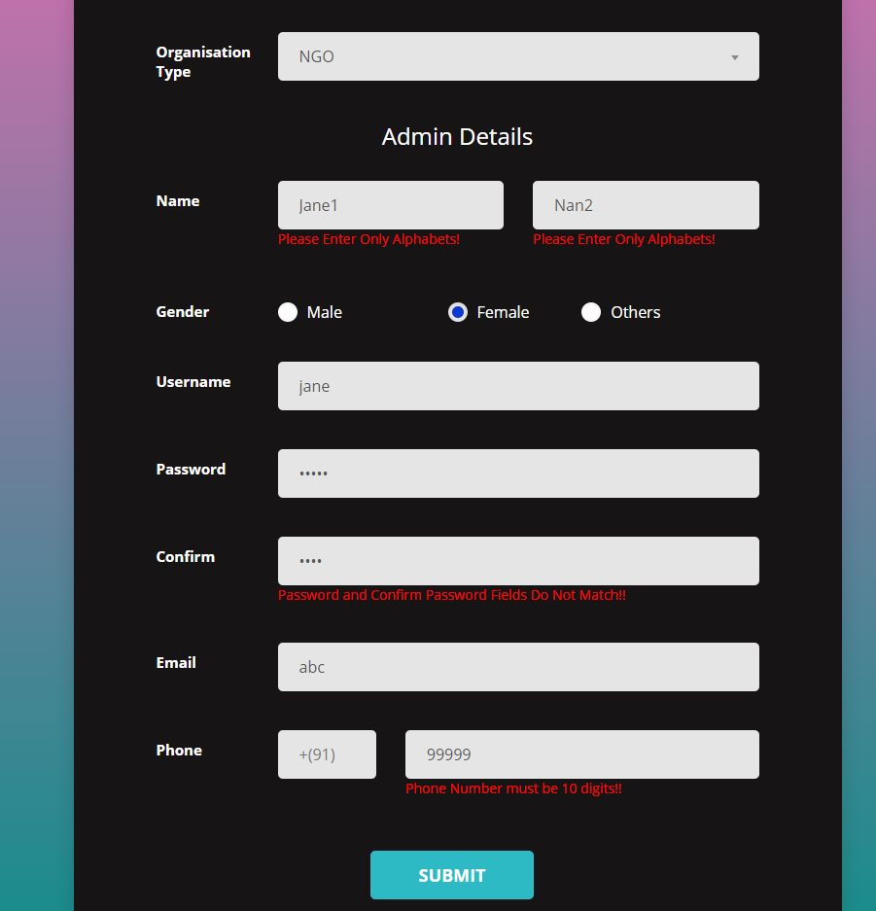

Fig 6.1 Admin Registration

1. In the below volunteer login page, the email, phone number, name, password fields and the blood group fields are validated to ensure the details are entered in the correct format.

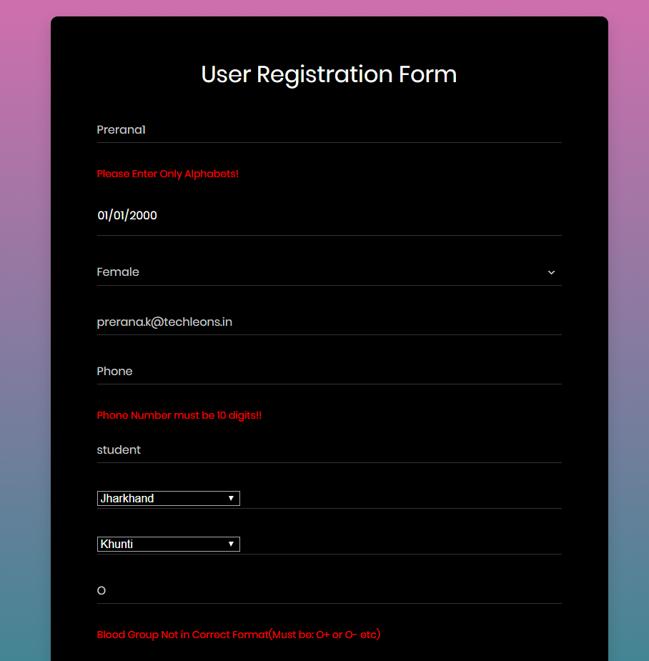Fig 6.2 Volunteer Registration part A

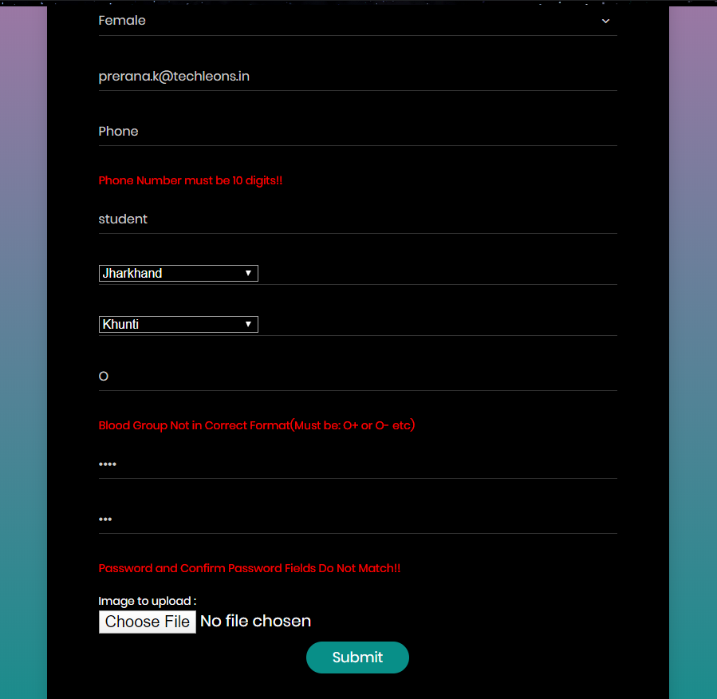

Fig 6.3 Volunteer Registration part B

1. In the below event registration page, the event name and type are left blank and hence an error is issued as null values are not allowed.

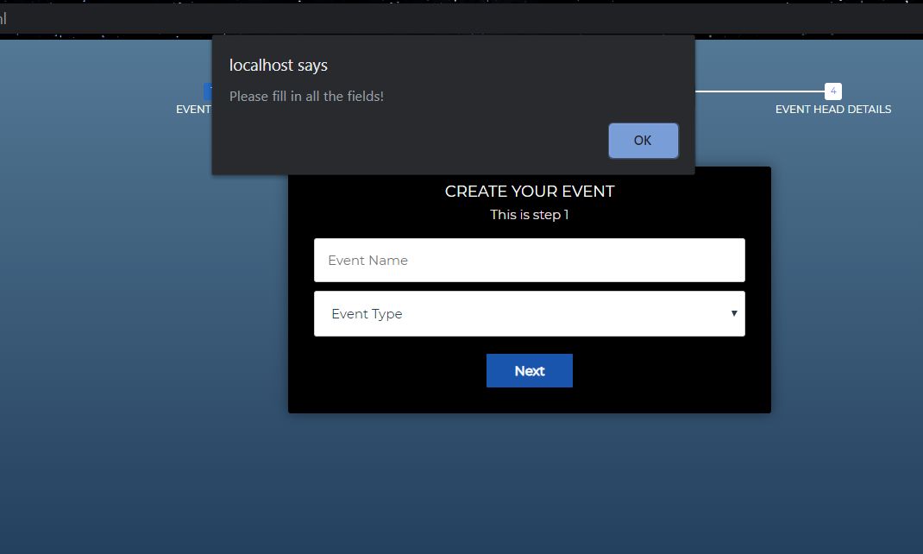

Fig 6.4 Event Details (Committee Creation)

1. The number of volunteers required for an event cannot exceed the number of committees in the event as there cannot be a committee with no volunteers. Hence, the error displayed below.

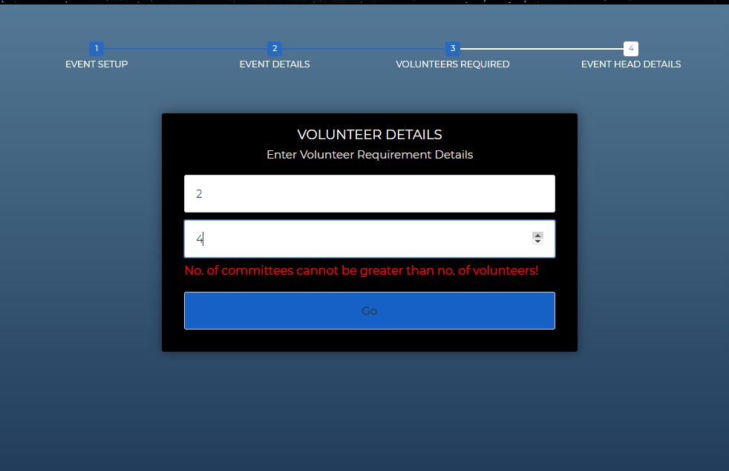

Fig 6.5 Volunteer Details (Committee Creation)

1. The event head details entered are expected to be in a specific format. The input entered below does not match this format and hence the error messages.

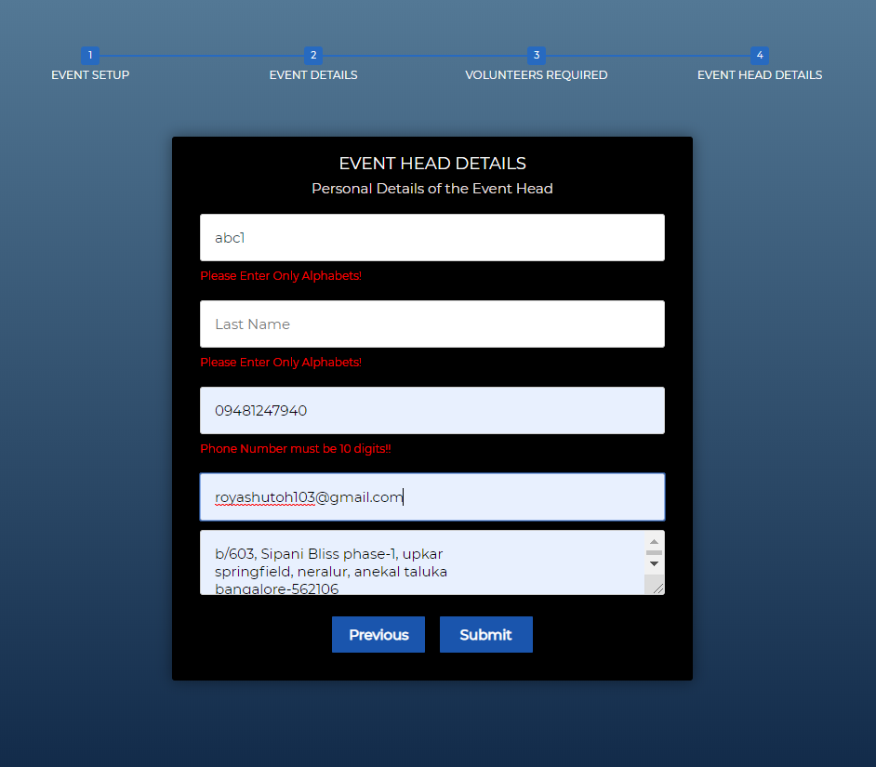

Fig 6.6 Event Head Details (Committee Creation)

1. **CONCLUSION**

Voluntaria helps non-profit organizations in various ways and makes doing charitable work a whole lot easier. Anyone who wishes to volunteer for a good cause can now do so with ease and in minimal amount of time. It will facilitate one organization to hold multiple events in one day and recruit and manage volunteers for these events by assigning event heads and allowing them to access and track volunteer data. The volunteer will receive rewards in the form of certificates or recommendation letters based on their performance and this might encourage them to volunteer more often.

Voluntaria is the solution to both the volunteer’s and an organization’s problems when it comes to organizing an event that will benefit a charitable cause.

* 1. **Limitations:**
* The existing security of the system is weak and can be compromised.
* Existing rating system is basic and can stand to be improved.

* 1. **Future Enhancement:**
* The security of the system would be enhanced and improved.
* The rating system will improve to provide the volunteer with better input and suggestions based on their performance during the event.

**REFERENCES**

[1] MySQL Table Creation and fixing anomalies: <https://www.w3schools.com/sql/>

[2] PHP Database Connections & Operations: <https://www.w3schools.com/php/php_mysql_connect.asp>

[3] Java-Script Validations for forms: <https://www.w3schools.com/js/js_validation_api.asp>

[4] CSS Code for styling responsive Webpages: <https://www.w3schools.com/css/css_rwd_intro.asp>

[5] Roger S. Pressman, Software Engineering A Practitioner’s Approach, 7th Edition, 2010.

[6] Elmasri Ramez and Navathe Shamkant B, Fundamentals of Database Systems, Addison Wesley, 6th Edition, 2010.